**Take screenshots of the completed programming exam (python code and output in python shell), paste them into a word document and upload it. Please submit your assignment with the naming convention of Lastname_Firstname_Practice_Programming_Exam3.docx.**

**10 points**

Organization of the code such as proper commenting out, meaningful variable names, declaring and calling functions such as calling helper functions in main function, following PEP 8 design, clean code, submitting the word document with properly pasted python code and output etc.

**20 points**

**Q1.** Write a function that takes a string argument and returns a dictionary containing the number of times each letter occurs in the string.

**Here is a sample dialog**

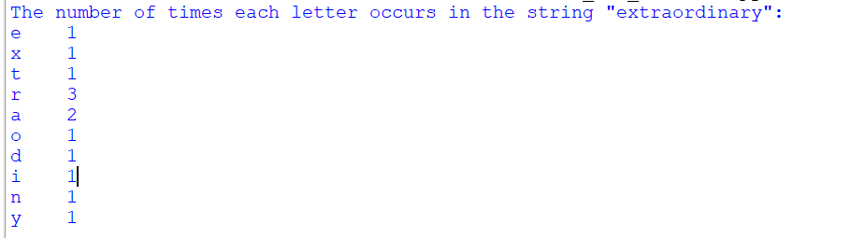

**35 points**

**Q2.** Implement a class Student and save it in a file named IC_student.py. For the purpose of this exercise, a student has a name and a total quiz score. Supply an appropriate constructor and methods getName(), addQuiz(score), getTotalScore(), and getAverageScore().

To compute the latter, you also need to store the number of quizzes that the student took.

Create a tester program named studentDemo.py and copy the code below to test your program.

**Here is a sample dialog**



**35 points**

**Q3.**  The superclass Person has two subclasses, Student and Instructor, that inherit from Person. A person has a name and a year of birth. A student has a major, and an instructor has a salary. Create the necessary classes.

**Here is a sample dialog**

